Interop ITX 2017— Business Justification Toolkit

Everything You and Your Manager Need to Know
Over five days at Interop ITX®, thousands of business technology professionals will discover the most current and cutting-edge technology innovations and strategies to drive their organizations' success in the areas of security, data management, DevOps, leadership, and more. From the keynotes to the six track topics to the events in the Business Hall, we'll help your company make the difficult decisions in order to optimize, profit from, and react to the transformation of our industry.
We've included a few materials that you can tailor to meet your needs and make things easier for you to get approval to attend Interop ITX, including:
- A letter template
- Interop ITX Schedule at a Glance
- What the media is saying
- Who attends Interop ITX
- An expense worksheet
With multiple Conference pass options and early-bird pricing, we're confident that you will be able to find the right package to fit your budget.
We look forward to seeing you in Las Vegas in May!
The Interop ITX Team

P.S.: Don't hesitate to reach out to us at interoplvregistration@ubm.com if we can provide you with any other information.

JUSTIFICATION LETTER TEMPLATE

Dear [Insert Name,
I am requesting your approval to attend Interop ITX, May 15–19, 2017, at the MGM Grand, Las Vegas. In its 31st year, Interop ITX is the only independent Conference for technology leaders where attendees can find trusted education developed by a team of objective practitioners and content professionals in the core areas needed to keep current on the skills and technology required for our business.
The Conference session tracks include:
- Infrastructure
- Security
- Data & Analytics
- Cloud
- DevOps
- Leadership & Professional Development
Over the course of five days, Interop ITX offers full- and half-day workshops, hands-on sessions, panels, and inspiring keynotes. I will also be able to interact directly with over 100 Exhibitors in the Business Hall, which will allow me to personally test and evaluate a range of technologies that are important to our business.
When I return from Interop ITX, I will be able to share and implement the latest IT trends and cutting-edge innovations with the rest of our organization. Interop ITX will also be a fantastic opportunity to make substantial, face-to-face connections with leading suppliers and service providers.
I've included a fact sheet for your review as well as a breakdown of the approximate cost of my attendance. You will find there are a number of different pricing options designed to fit our needs. With all of these opportunities to learn from industry leaders and connect with some of the top companies in the country, I hope you see the value of this event.
Please review these materials and let me know if you have any questions.
Sincerely,
[Signature]

EVENT SCHEDULE

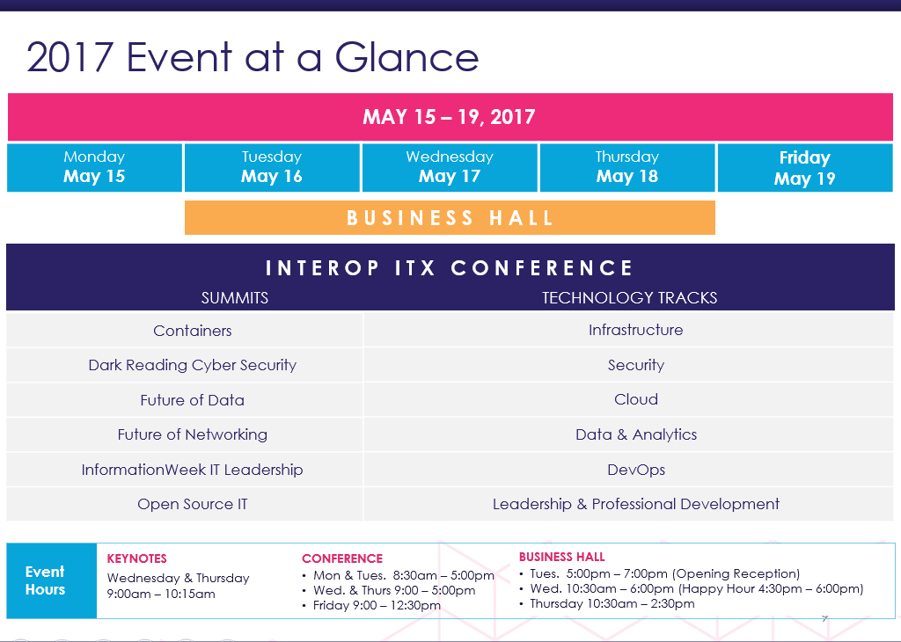

Link to: Full Conference Information

What the Industry Is Saying about Interop ITX
"Interop is one of those granddaddy technology shows where CIOs from around the world look to the hundreds of vendors who come to showcase their latest and greatest products and services as a barometer for what's next." —Forbes Magazine
"Interop has evolved with the particular needs of the time, going from what was once a 'purely technical' experience to one that combines technology with larger factors including industry trends, changing business models and the new landscape of decision making." —Network Computing
"One thing I've always loved about Interop is that you can see the future of networking now. That may sound like a cliché, but for any networking challenge you are having, you'll usually find numerous solutions." —Wired Magazine
"Interop continues to be one of the most important independent conferences and it really shows, thanks to your commitment. We were very impressed by the quality of presentations and presenters at the event and loved seeing so many of our friends and colleagues during the show. The expo was also a great chance for us to talk to some previous Tech Field Day presenters and get caught up with some new companies as well. Only at Interop can we find all of those things in one package!" —Tom Hollingsworth, Architect, The Networking Nerd
"I went out of my way to chat personally with Interop attendees, mostly at meals, in the Expo, and between sessions. I'm almost embarrassed to say I couldn’t find anyone who had a complaint. The 25 people I talked to complimented almost every aspect of Interop. On top of everything else, I had a good time. I have a geek blog that is pretty widely read, mostly because when something is bad, I bash it hard. But for Interop I could only write good things." —James McCaffrey, Research Scientist, Microsoft Research
"I also took a full week of paid time off to attend the Interop workshops and network with speakers, vendors, and fellow attendees. Because the experience was simply awesome and something I wish to repeat again next year, I thought it'd be worth posting what I've learned and why I found so much value in going. It's a rare treat to find a truly exceptional place to learn and network. Most conferences are entirely too product and sales focused, or float up at such a high level that it feels like you're just being lectured to without any real meat." —Chris Wahl, President, Wahl Network

Who Will I Meet at Interop?

Sample Job Titles of Past Attendees
- District CIO  - Chief Technology Officer  - IT Director  - IT Specialist  - Sr. Server/Network Administrator  - IT Project Manager | - Infrastructure Architect  - EVP Technology  - Principal Network Architect  - Director, Infrastructure & Security  - Tech Analyst  - Vice President for Information Resources

Sample Companies of Past Attendees
- ARMtech | - Northrop Grumman
- Bank of America | - PayPal
- Benefit Cosmetics | - PricewaterhouseCoopers
- California Dept. of Corrections | - Quest Diagnostics
- Cox Communications | - Raytheon
- Cirque du Soleil | - Salesforce.com
- City of Los Angeles | - Sony Electronics
- Dept. of Defense | - The Liberty Group
- El Pollo Loco | - Thrifty Corp.
- Ericsson | - Toyota
- Fidelity National Title | - Tropicana Hotel and Casino
- Hard Rock Hotel | - U.S. Air Force
- High Liner Foods | - U.S. Navy
- Honeywell | - Venetian Resort
- In-N-Out Burger | - Wells Fargo
- Lockheed Martin | - Yahoo!

EXPENSES WORKSHEET
Please fill out this expenses worksheet to estimate the cost of attending Interop ITX 2017.
Note that the Interop ITX attendee negotiated room rate for the MGM Grand is $109 a night for a standard room!

Interop ITX  Conference registration | Select the pass that fit your needs:  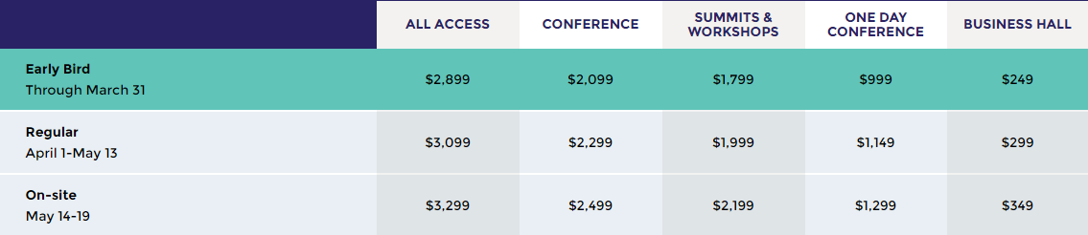  $
Flight | $
Transportation | $
Mileage reimbursement | $
Lodging | $
Food per diem | $
Total | $

